Ezekiel

Goals of this study:
a) Learn techniques for studying the Bible.
b) Learn what Ezekiel has for us to know.

Week 1: (Chapter 1:1-16
We learned what the name Ezekiel means: (God Strengthens or Whom God Strengthens)
Read about the most impressive sight witnessed by Ezekiel himself of God’s transportation.
Read descriptions of various creatures which we discovered must be Cherubim.
There were 4 distinct creatures represented: Ox, Eagle, Man, Lion: WE saw a difference in Ez Ch 10.

We looked for Bible verses to help us understand the meaning behind the descriptive cherubim. The book of numbers talks about the camp of Israel as they positioned themselves around the Holy of Holies. The Talmud which is the central text of Rabbinic Judaism contains the descriptions of the standards so we can deduce the following structure.

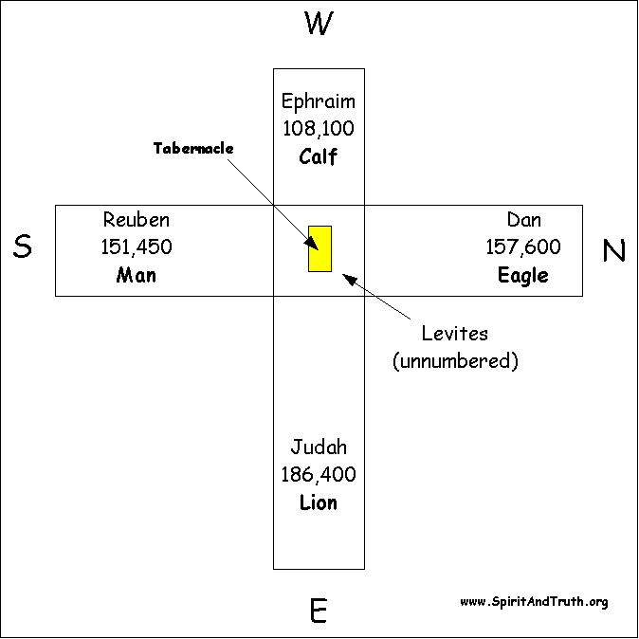

This implies that Ezekiel, who was obviously an Israelite, would recognize the faces as being that of God. They were even positioned properly on the vehicle of God.

WEEK 2: Chapter 1 completed as well as Chapter 2 & 3 complete.
Chapter 1 conclusion
This week we continued and finished talking about the special vehicle that God used to visit and carry Ezekiel away as written in chapter 3. Though the descriptive language is difficult, it isn’t hard to imagine how difficult it would be to describe something as amazing as this without a frame of reference. It’s relevance to us is probably not overly critical to our understanding of Ezekiel’s prophecies, however if we were to see this vehicle, with the emblems and living creatures come flying down to visit us, at least we know who it is!

Chapter 2 is only a few verses, but basically describes the spiritual condition of Israel and how Ezekiel should act in accordance with God’s directions. To break chapter 2 down simply:
a) Israel – stubborn, stiff-necked, and difficult even to prior generations.
b) Ezekiel – don’t be afraid, don’t be rebellious, take only what I give you for words to say.
c) A scroll is presented written inside and out, which means complete with “NO MORE ROOM” for further prophetic words to be spoken from Ezekiel’s mouth.
d) The scroll was filled with really bad things for Israel to consider.

Chapter 3 Highlights
a) Eat the complete prophecy and you won’t be able to add anything to it because your lips will be sealed until I (GOD) unseals them.
b) Israel is still and will be stiff-necked and stubborn beyond belief, however….
c) God made Ezekiel just as difficult and stubborn to contest with the house of Israel.
d) Ezekiel gets dropped down in the midst of those in captivity and nothing is said for seven days.
e) God plainly tells Ezekiel that Israel’s fate and the fate of his own soul is in the performance of his duties.
f) God only really wants to talk to people who are on their feet!
g) THUS SAITH the Lord God has special significance as he is announcing himself a prophet of God.

Chapter 4 Highlights
a) Ezekiel’s odd behavior of lying on his left side and right side helped signify he came from God.
b) 390 days for Israel = 390 years, 40 days for Judah = 40 Years. Sum of 430 Years; so what? Turns out that 430 years is in a few places. Ex 12:40-43. It also appears that Ezekiel time to the the Passover Lamb would have been 430 years. The time between covenant and Abraham was 430 years.
c) Jerusalem drawn/modeled and an iron plate signified that Israel was going to face it alone.
d) The bread cooked over dung signified that Israel/Judah was bad. Bread = Doctrine.

When we read the Bible, we should consider certain things as being used as examples spiritually. (1st Cor 10:11) The Old Testament is mostly real and physical pictures of the future spiritual situation. For prophetic value, numbers, however they are used is important. Sometimes they are hidden. Some examples of words we should know their spiritual value are: bread, sword, leaven, stars, oil, fire numbers of anything, etc…) We need to be on the lookout for them in prophecy to help us really understand. Yes it is hard.

Chapter 5 Highlights
So last chapter it was all about laying down on each side of his body for the number of days that Israel and Judah would be punished. This time Ezekiel had to shave off his beard and do bizarre things with them. Chapter 4 was how long and Chapter 5 describes a bit of the how the punishment will take place.
- It was going to be done in the presence of the surrounding nations so they could see the what happens and will be instructive for everyone.
- There will be famine and pestilence (By the way, same things are spoken in Revelation.
- We saw that the punishment was clearly spoken of in Leviticus if they did not behave properly.
- A remnant will be scattered into “all the winds” which of course means everywhere.

